**Frontend Development with React.js**

**Project Documentation format**

1. **Introduction:** The Cryptoverse Dashboard is a comprehensive and user-friendly platform designed for cryptocurrency enthusiasts and investors.
   * Project Title: cryptoverse:A cryptoverse dashboard
   * **Team Members**: **Team id: SWTID1741230716155965**

**1**.D.Swetha - ponniswetha2022@gmail.com

**2**.M.Vinodhini - Vinovino1883@gmail.com

**3**.A.Tharunya – tharunyaanandhan@gmail.com

**4**.M.Thamizharasi - thamil0231@gmail.com

1. **Project Overview**
   * **Purpose**: Cryptoverse is a sophisticated cryptocurrency dashboard designed to provide investors with comprehensive insights into market dynamics through detailed historical price data analysis spanning five years. Featuring visually intuitive charts, interactive tools, and seamless navigation, the platform empowers users to identify top-performing assets and make informed investment decisions. With its robust search functionality, users can easily explore a wide range of cryptocurrencies and compare their performance over time. Cryptoverse not only serves as a powerful tool for optimizing investment portfolios but also acts as an educational resource, helping users understand the evolving nature of cryptocurrency markets.

### • **Authentication and Security**: Add Features: • **Cryptocurrency Tracker**: Display real-time data for various cryptocurrencies, including price, market cap, volume, and price changes over different timeframes

### • **Interactive Charts**: Provide detailed and interactive charts for price history and trends, allowing users to analyze data over multiple time segments.

### • **Portfolio Management**: Enable users to track their investments, calculate profit/loss, and manage their cryptocurrency portfolio2

### • **News and Updates**: Integrate a news section to keep users informed about the latest developments in the cryptocurrency world

### • **Currency Converter**: Include a tool to convert between cryptocurrencies and fiat currencies.user authentication for personalized features like portfolio tracking and secure data storage.

### • **Responsive Design**: Ensure the dashboard is mobile-friendly and accessible on various devices.

### • **API Integration**: Use APIs like CoinGecko or CryptoCompare for fetching real-time data

1. **Architecture**

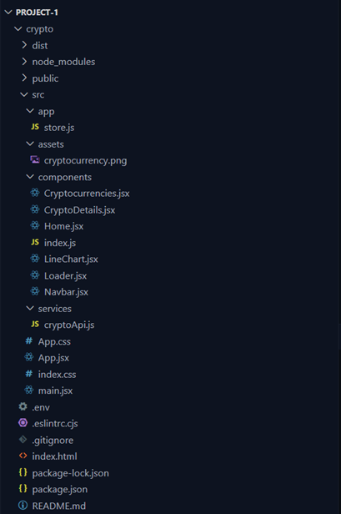

1. **Setup Instructions**
   * Prerequisites: React.js: Node.js and npm
   * Install Node.js and npm on your development machine, as they are required to run JavaScript on the server-side
   * Installation: Create a newReactapp: npx create-react-app my-react-app Replace my-react-app with your preferred project name.
   * ●Navigate to the project directory: cd my-react-app
   * ●Running the React App: With the React app created, you can now start the development server and see your React application in action. ●Start the development server: npmstart This commandlaunches the development server, and you can access your React app at http://localhost:3000 in your web browser
2. **Folder Structure**

**cryptoverse-dashboard/**

**├── public/ # Static files**

**│ ├── index.html # Main HTML file**

**│ ├── favicon.ico # Favicon**

**│ └── assets/ # Images, fonts, etc.**

**├── src/ # Source files**

**│ ├── components/ # Reusable components**

**│ │ ├── Header.js**

**│ │ ├── Footer.js**

**│ │ └── CryptoCard.js**

**│ ├── pages/ # Page components**

**│ │ ├── HomePage.js**

**│ │ ├── Dashboard.js**

**│ │ └── About.js**

**│ ├── services/ # API calls and services**

**│ │ └── cryptoAPI.js**

**│ ├── styles/ # CSS or SCSS files**

**│ │ └── main.css**

**│ ├── utils/ # Utility functions**

**│ │ └── helpers.js**

**│ ├── App.js # Main app component**

**│ ├── index.js # Entry point**

**│ └── store/ # Redux or state management**

**│ └── store.js**

**├── .gitignore # Git ignore file**

**├── package.json # Project metadata and dependencies**

**└── README.md # Project documentation**

1. **Running the Application**
   * + **Frontend**: npm start in the client directory.
2. **Component Documentation**

Key Components: Header Component:

* Contains navigation links (e.g., Home, Cryptocurrencies, News, About).
* Displays the project title or logo.

Footer Component:

* Includes contact information, copyright details, and links to social media.

CryptoCard Component:

* Displays summarized data about a cryptocurrency (e.g., name, price, market cap).
* Designed for a responsive grid layout.

Dashboard Component:

* Shows a detailed overview of top cryptocurrencies with charts and tables.
* Could include data visualizations like price trends or market dominance.

Search Component:

* Allows users to search for specific cryptocurrencies.
* Filters or updates results dynamically.

Detail Page Component:

* Displays detailed information about a selected cryptocurrency.
* Could include historical data charts, market statistics, and links to resources.

NewsFeed Component:

* Fetches and displays the latest news related to cryptocurrency.
* Shows headlines, links, and summaries.

API Integration (Service Layer):

* Handles data fetching using services like CoinGecko, CryptoCompare, or similar APIs.
* Consolidates API calls to keep components clean.

Error Boundary Component:

* Captures and displays user-friendly error messages for failed API calls or runtime errors.

Loader/Spinner Component:

* Provides visual feedback while data is being loaded.

Pagination/Infinite Scroll:

* Allows smooth navigation through lists of cryptocurrencies or news articles. Global State Management:
* Manages app-wide state using Redux or React Context for better performance.

Theme Toggle:

* Allows users to switch between light and dark themes.

Chart Component:

* Visualizes trends using libraries like Chart.js, Recharts, or D3.js.

Authentication Component (if needed):

* Handles user login and signup for personalized features like watchlists.
* Reusable Components: Detail any reusable components and their configurations.

**8.State Management**

* **Global State**: React.js project like Cryptoverse, where you might deal with data such as user authentication, cryptocurrency details, or pricing trends, global state management ensures that this data is accessible to all relevant components without passing props down through numerous layers. Popular tools for global state management in React are Redux, Context API, or Zustand.

1. **Local State**: **Initialization**: State is initialized using hooks like useState. For instance:

javascript

const [searchQuery, setSearchQuery] = useState('');

1. **State Updates**: State changes are handled with the state setter function (e.g., setSearchQuery). Changes might occur based on user input or other events, updating only the component they belong to.
2. **Component Behavior**: Local state drives the behavior and appearance of the specific component. For example, the search bar's value updates dynamically as the user types.

**9.User Interface**

* provide screenshots or GIFs showcasing different UI features, such as pages, forms, or interactions.
  + A cryptocurrency UI would typically include:
    - A dashboard displaying real-time cryptocurrency prices.
    - Wallet functionality (balance, transaction history).
    - Trading interfaces (buy/sell orders).
    - Charts **and** graphs for price analysis.
* **UI Features:**
  + **Pages:** Home (dashboard), Wallet, Trade, Market, News.
  + **Forms:** Buy/Sell order forms, wallet address input.
  + **Interactions:** Clickable price charts, interactive order books, real time data updates.
* **Screenshots/GIFs:**
  + Imagine:
    - A live price chart updating with smooth transitions (GIF).
    - A clean, responsive dashboard showing your portfolio balance (screenshot).
    - A buy/sell form with input validation, and confirmation modals.

**10**.**Styling**

* **CSS Frameworks/Libraries**:
* CSS frameworks, libraries, or pre-processors (e.g., Sass, Styled-Components) used.
  + **Material UI or Ant Design:** Excellent for pre-built, consistent components.
  + **Tailwind CSS:** For rapid, utility-first styling.
  + **Styled-Components:** For CSS-in-JS, allowing component-specific styles.
* **Theming:**
  + Explain if theming or custom design systems are implemented.
  + Implement a theme context using React's Context API to allow users to switch between light and dark modes.
  + Custom design systems would involve creating a set of design tokens to ensure consistency in spacing, typography, and colors.

**11. Testing**

* **Testing Strategy:**
  + **Unit Tests (Jest + React Testing Library):**

Test individual components in isolation (e.g., a price display component).

* + **Integration Tests:**

Test how components interact with each other (e.g., a trading form submitting data).

* + **End-to-End Tests (Cypress or Playwright):**

Test the entire application flow (e.g., user login, placing an order).

* **Code Coverage:**
  + Use Jest's built-in coverage reports or tools like nyc to ensure a high percentage of code is covered by tests.

**12. Screenshots or Demo**

<https://drive.google.com/file/d/1Hlj9AXuDseNhIBtrp531urGdyQpzh6qV/view?usp=drivesdk>

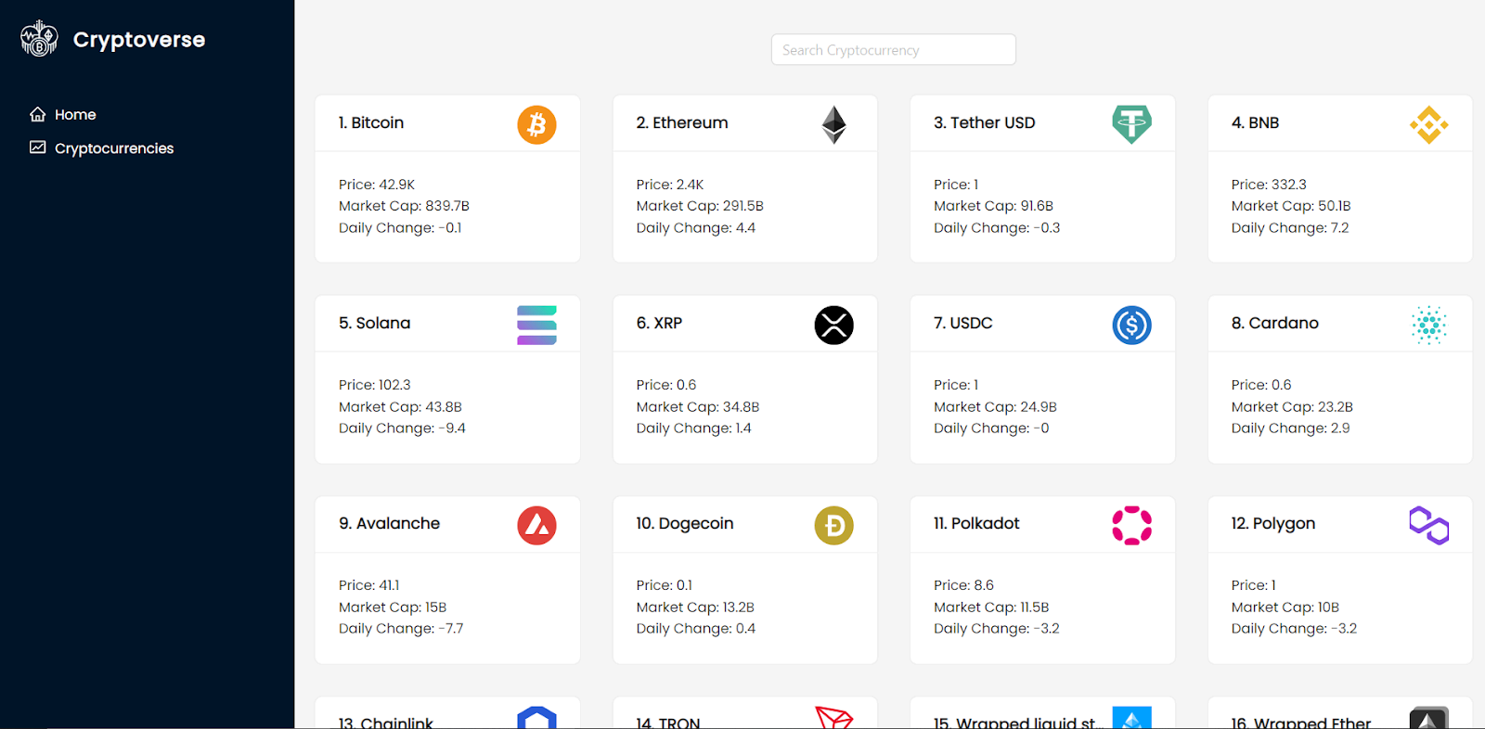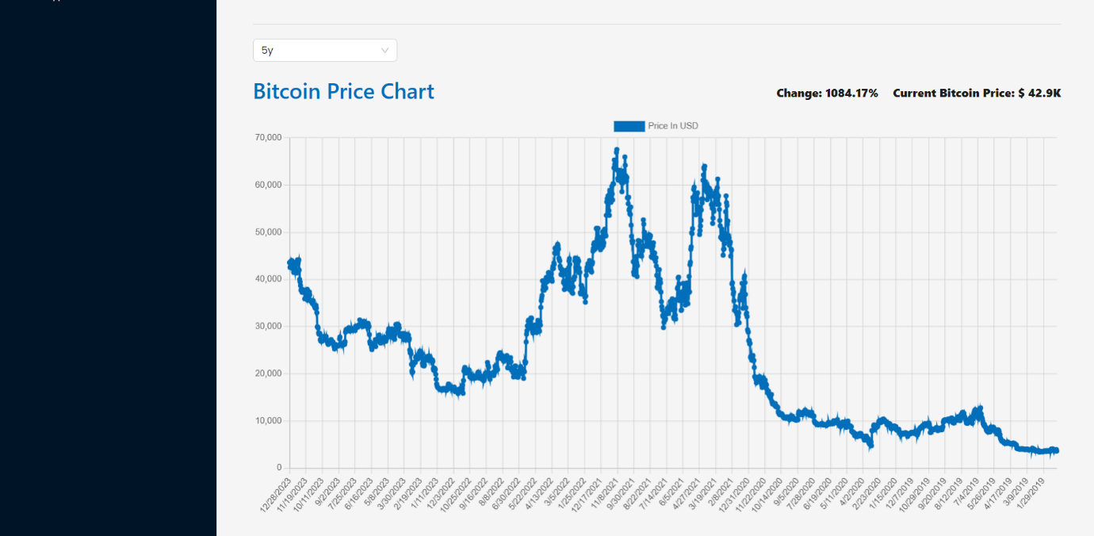

**13. Known Issues**

* Document potential issues:
  + Slow performance with large datasets.
  + Compatibility issues with certain browsers.
  + Potential delays in real-time data updates.
  + Issues with edge cases in form validation.

**14. Future Enhancements**

* **Potential Features:**
  + Advanced charting tools.
  + Portfolio tracking and analysis.
  + Integration with more cryptocurrency exchanges.
  + Mobile app development (React Native).
  + More complex order types.
  + Enhanced security features.
* **Improvements:**
  + Improved performance optimization.
  + Accessibility improvements.
  + Enhanced user experience.
  + Adding more animations,